Gabriel Emerson

ELEC 2210 – T 11:00

Experiment #10 CMOS Logic Circuits

03/23/2021

**Introduction**:

The goal of this lab is to experiment with NMOS and PMOS transistors and understand how to connect them to form CMOS inverters. CD4007 chips will be used to form inverter chains, transmission gates, and D-latches. This lab will provide further experience on the NI Elvis Board and knowledge of CMOS inverter characteristics.

**Step 1: CMOS Inverter Chain**

Using a CD4007 chip and the connections provided in the manual, an inverter chain was constructed on the wiring board. Using probes, the output of each inverter was taken and displayed on the oscilloscope. As expected, the signal inverted after going through the inverter. The square wave also became more defined after passing through each inverter, having sharper transitions. These changes can be observed in the figures below.

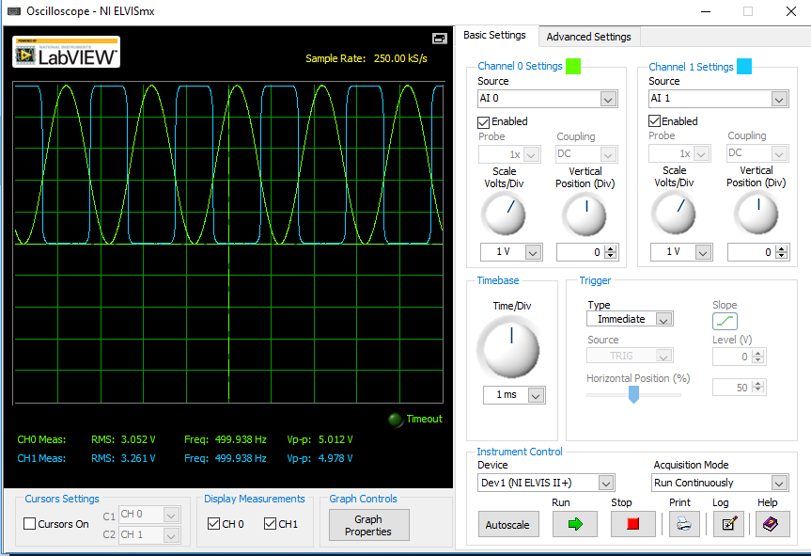

Figure 1: First Inverted Output

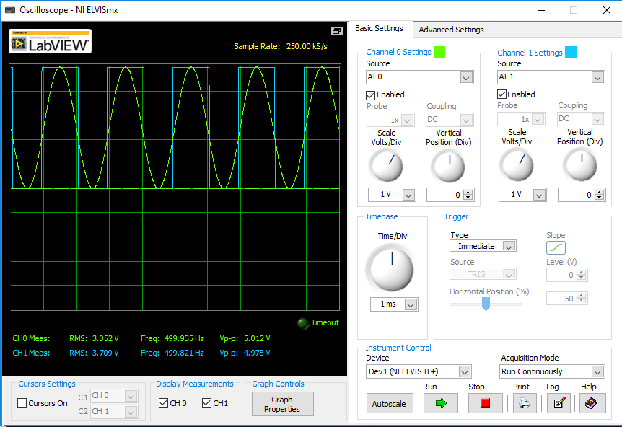

Figure 2: Second Inverted Output

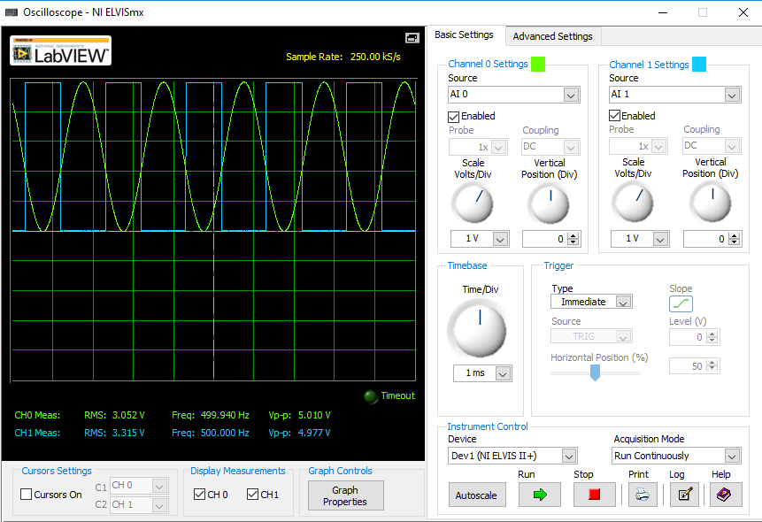

Figure 3: Third Inverted Output

**Step 2: CMOS Transmission Gates**

Using a new CD4007 chip, the diagram, and the connections provided in the lab manual, a transmission gate was constructed on the wiring board. The function generator was used to produce a 500Hz square wave with a 5V peak to peak value. To test functionality, the Digital Writer was used to simulate clock pulses and the waveforms were evaluated on the oscilloscope. Screenshots of the results can be seen below.

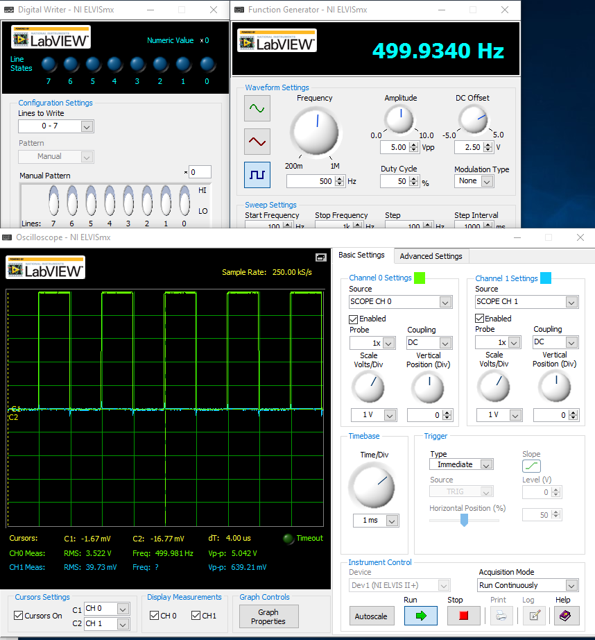

Figure 4: Clock = 0

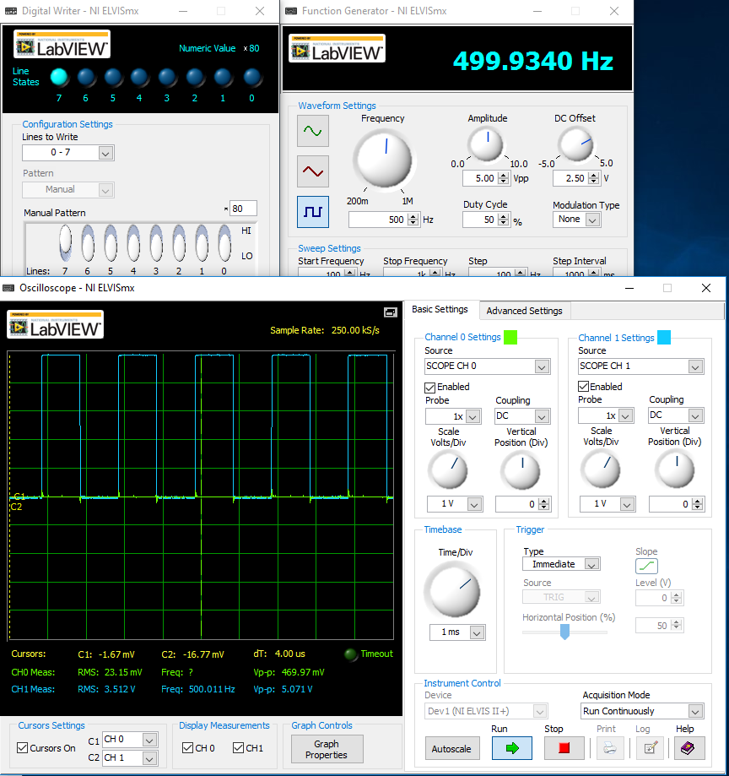

Figure 5: Clock = 1

**Step 3: D-Latch**

Combining the circuits from Step 1 and 2, a D-Latch was created. When the clock signal was logic low, the latch was in a transparent phase. This means that the input to the latch would also be the output. When the clock was logic high, whatever value was in the latch previously would be held. These results can be seen below.

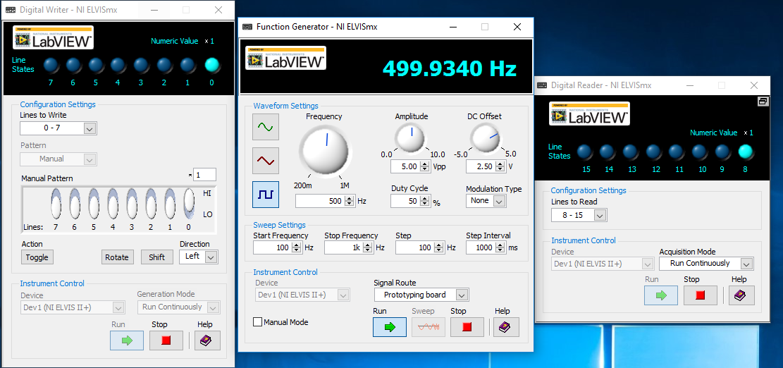

Figure 6: Input High – Output High

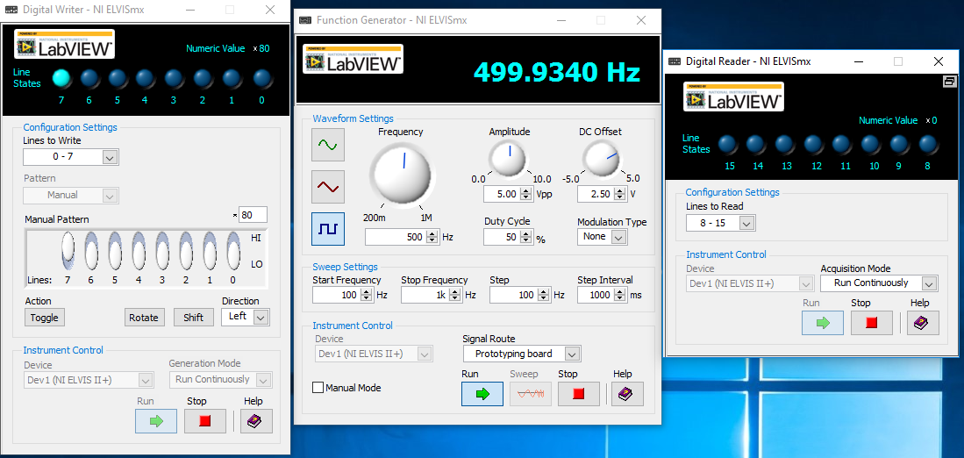

Figure 7: Holding Previous Output

**Bonus: Master-Slave D Flip-Flop**

To convert the D-Latch to a D Flip-Flop, a copy of the Step 3 circuit was created with an inverted clock signal. If correctly assembled, one should be able to determine if it is rising edge or falling edge triggered as well as test the Flip Flop logic for functionality. Below I have figure 8, which shows the output voltage of the second inverter and voltage across the capacitor. In figure 9, it shows the output voltage of the second inverter and the voltage at node C.

Figure 8: Master-Slave D Flip Flop

Figure 9: Master-Slave D Flip Flop

**Conclusion**:

After completing this lab, I am more confident on how to use a CD4007 as a CMOS inverter and how to use multiple chips to create a chain of inverters. I can see how this might come in handy during the final lab design. I also learned how to create a D-latch which will help in the future for logic diagrams. I was slightly confused at first when assembling the flip flop in the bonus. However, I think that I gained a lot from this lab and that it was good preparation for the wiring difficulty that will be on our lab final.

